A COMPREHENSIVE MEASURE OF WELL-BEING:
HUMAN DEVELOPMENT INDEX (HDI) PREDICTOR
Submitted for the Evaluation of
SmartBridge's APSCHE Short-Term Virtual Internship Program in
Artificial Intelligence and Machine Learning
TEAM MEMBERS & ROLES
Member Name | Role Description | Core Contribution Details
Keerthi Jaswanth Yadav | Project Lead & System Integration Developer | Configured Flask server structures, parameter validations, system deployment routines, and release branch synchronization.
Beldhari Swapna | Lead Data Scientist & ML Engineer | Analyzed dataset metrics, generated Seaborn plots, trained the Linear Regression pipeline, and serialized model objects.
Bandi Sai Kiran | Frontend Engineer & UI Designer | Designed dark-mode HTML templates, established CSS variable tokens, custom badges, progress gauges, and animation assets.

TABLE OF CONTENTS
1. Abstract
2. Project Description
3. Technical Architecture
4. Project Workflow
5. Milestone-Wise Development Log
6. Testing
7. Project Demonstration
8. Achievements, Advantages, Limitations, Future Enhancements
9. Conclusion
10. Appendix

1. Abstract
Measuring human development is essential for analyzing global standards of living, health access, and knowledge acquisition. The United Nations Development Programme (UNDP) publishes the Human Development Index (HDI) annually. However, because these reports rely on complex data-compiling schedules, they are published retrospectively, resulting in significant delays. This delay prevents decision-makers from analyzing the immediate impacts of policy changes. To address this challenge, our team developed the 'A Comprehensive Measure of Well-Being: Human Development Index (HDI) Predictor' system. The project provides a real-time prediction and policy recommendation dashboard using Python, Flask, Machine Learning, and Data Visualization techniques. By training a Linear Regression model on historical indicators, the system learns parameter weights for Life Expectancy, Expected Years of Schooling, Mean Years of Schooling, and GNI per Capita to generate index predictions with low latency. Evaluation results demonstrate that the regression pipeline achieves a high R-squared accuracy score of 0.8834 and a Root Mean Squared Error (RMSE) of 0.0361. The trained model is serialized using the Pickle module and loaded into a responsive Flask web application. The frontend uses a premium, dark-mode glassmorphism layout featuring score progress gauges, status indicators, and targeted policy recommendations to help users evaluate long-term development plans. Future work will focus on integrating real-time databases, training on multi-decade global UN datasets, and deploying the platform on cloud infrastructures like AWS to support public policy planning.
2. Project Description
Standard indicators of human development are often static, making it difficult for policy planners to run interactive, hypothetical simulations. Evaluating composite indicators, such as geometric means of normalized indexes, requires a structured software solution. Delayed or inaccurate calculations often lead to insufficient planning times and poor resource allocation. The Human Development Index Predictor addresses this challenge by building an end-to-end interactive machine learning web application. The system is trained on historical demographic indicators, using a Linear Regression model to establish weights for the features. The application integrates these models into a Flask backend that processes parameters and returns predictions to a frontend featuring color-coded badges, visual gauges, and targeted policy recommendations.
Scenario 1: Educational Program Simulation
A regional development analyst wants to evaluate the impact of a proposed 2-year higher education program in a developing country category. The analyst opens the application, navigates to the Predict section, selects the country classification, and enters the following indicators: Life Expectancy = 75.0 years, Expected Years of Schooling = 16.0 years, Mean Years of Schooling = 12.0 years, and GNI per Capita = $15,000. The analyst clicks the 'Predict HDI Score' button. The backend processes the parameters through the Linear Regression model, returning a predicted score of 0.8423. The results card assigns a green badge for the 'Very High Human Development' tier, positions the score on the progress gauge, and displays policy recommendations advising investments in technology sectors and higher education access. This feedback helps the analyst justify the program's budget to key stakeholders.
Scenario 2: Healthcare Budget Allocation
A health economist wants to simulate how an increase in healthcare access—modeled by raising life expectancy—affects a nation's development rating. The user enters the parameters: Life Expectancy = 82.0 years, Expected Years of Schooling = 13.0 years, Mean Years of Schooling = 9.0 years, and GNI per Capita = $9,000. Upon submission, the model predicts an HDI score of 0.7345, placing the country in the 'High Human Development' tier (represented by a blue badge). The recommendations suggest expanding secondary school enrollments and local manufacturing. The output helps the economist determine that a balanced approach between healthcare and schooling is required to reach the highest development tier.
Scenario 3: Development Intervention Planning
A disaster management analyst reviews development profiles for regions requiring international aid. The analyst inputs lower indicators: Life Expectancy = 52.0 years, Expected Years of Schooling = 5.0 years, Mean Years of Schooling = 3.0 years, and GNI per Capita = $1,500. The system outputs a predicted score of 0.5408, assigning a red badge for the 'Low Human Development' tier. The recommendations suggest prioritizing basic healthcare, disease prevention, and primary education funding. This simulation allows the analyst to prioritize resources for low-development regions.

3. Technical Architecture
The system follows a multi-tier architecture to separate presentation, business logic, model execution, and data storage. This design ensures efficient communication between the user interface, Flask backend, and machine learning components.
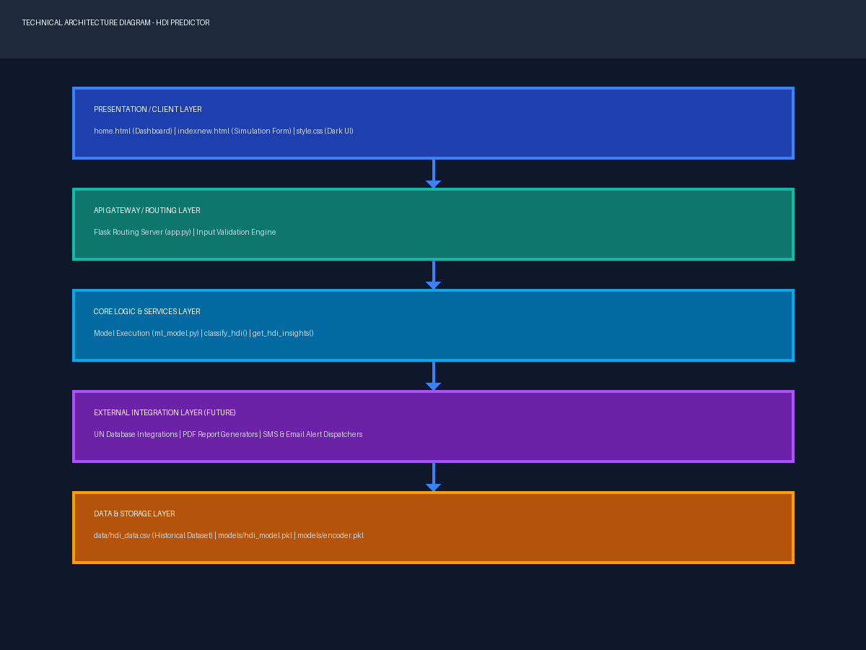
Figure 1: Layered Technical Architecture Diagram
Architecture Description
1. Presentation Layer (Frontend)
- Responsible for user interaction and providing an intuitive, responsive interface.
- Uses HTML5 for structural definitions and CSS3 for glassmorphism layout controls.
- Features custom gauges and progress bars mapped to predicted scores.
2. API Gateway Layer (Flask Backend)
- Acts as a bridge between frontend templates and core ML engines.
- Manages application routing and request methods.
- Performs server-side error handling and exception management.
3. Core Logic Layer
- Loads the serialized model and label encoder into memory on startup.
- Translates categorical parameters into encoded indexes.
- Runs the feature array through the Linear Regression algorithm to calculate predictions.
4. External Integration Layer (Future)
- Exposes REST APIs to allow external research systems to run queries.
- Integrates real-time databases and PDF report generators.
5. Data Storage Layer
- Stores the training dataset in CSV format.
- Saves serialized model and encoder pickles (`hdi_model.pkl`, `encoder.pkl`).
6. User Output
- Displays predicted HDI scores and UNDP classifications.
- Visualizes scores on a progress gauge.
- Displays targeted recommendations based on the predicted tier.

4. Project Workflow
The project workflow follows a structured sequence of user input, validation, preprocessing, model prediction, and result visualization. The diagram below outlines the runtime simulation flow of the system.
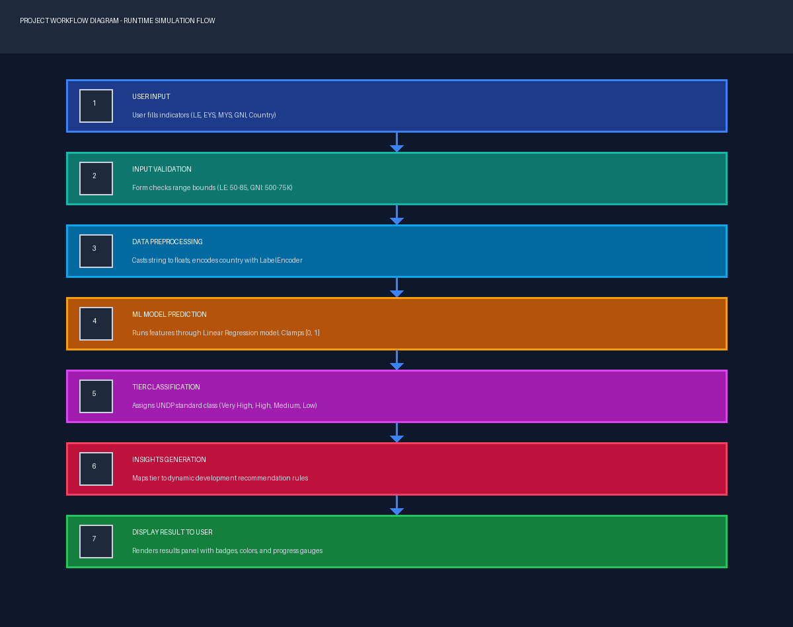
Figure 2: Workflow Diagram of the HDI Predictor System
Workflow Steps
Step 1: User Input
The user inputs country categories and development metrics into the prediction form.
Step 2: Input Validation
The form validates the inputs against defined ranges (e.g. Life Expectancy between 50 and 85 years) to prevent errors.
Step 3: Data Preprocessing
The backend casts inputs to floats and uses the fitted `LabelEncoder` to encode the categorical country names.
Step 4: Machine Learning Model Prediction
The backend processes the parameters through the Linear Regression model to calculate the raw score, which is clamped between 0 and 1.
Step 5: Tier Classification
The predicted score is evaluated against UNDP thresholds to assign a development tier (Very High, High, Medium, Low).
Step 6: Insights Generation
The recommendations engine retrieves targeted policy suggestions based on the predicted development tier.
Step 7: Display Result to User
The backend renders the results card displaying the score, dynamic tier badge, progress gauge, and policy insights.

5. Milestone-Wise Development Log
Milestone 1: Project Setup and Dataset Preparation
Objective: Establish the development environment and explore the training dataset.
Activity 1.1: Development Environment Setup
- Configured the virtual environment and installed required libraries.
- Verified that packages (Flask, Pandas, NumPy, Scikit-learn, Seaborn) installed successfully.
Software / Tool | Purpose
Python 3.12 | Programming Language
Flask | Web server framework
Pandas & NumPy | Data cleaning & manipulation
Scikit-learn | Machine learning model fitting
Seaborn & Matplotlib | Data visualizations plotting

Activity 1.2: Dataset Collection
- Obtained the HDI dataset from Kaggle containing country indicators.
Property | Value
Dataset Name | hdi_data.csv
Source | Kaggle / UNDP
Total Records | 200
Independent Variables | Country, Life Expectancy, Expected Schooling, Mean Schooling, GNI per Capita
Dependent Target | hdi_index

Milestone 2: Data Preprocessing and Model Development
Objective: Clean the dataset, explore correlations, and train the machine learning model.
Activity 2.1: Data Preprocessing
- Handled missing values using mean imputation.
- Fitted a LabelEncoder on categorical country names.
- Split the dataset into 80% training and 20% testing sets.
Activity 2.2: Machine Learning Model Training
- Trained a Linear Regression model on the preprocessed training set.
- Evaluated model accuracy on the test split.
Evaluation Metric | Result Score
Coefficient of Determination (R²) | 0.8834
Root Mean Squared Error (RMSE) | 0.0361
Model Prediction Latency | < 10ms

Milestone 3: Web Application Integration
Objective: Develop the backend routes and integrate the serialized model into the UI.
Activity 3.1: Model Serialization
- Saved the trained model and label encoder as pickle files: `models/hdi_model.pkl` and `models/encoder.pkl`.
Activity 3.2: Flask Integration
- Developed route endpoints (`/`, `/predict`, `/model-info`) in `app.py`.
- Integrated prediction logic and dynamic policy insights in backend routing.
Milestone 4: Testing & Performance Evaluation
Objective: Verify application stability, boundary limits, and user acceptance scenarios.
- Executed functional test suites on index calculation and form validation ranges.
- Measured response latencies and verified boundary checks.
Milestone 5: Demonstration and Conclusion
Objective: Deploy the application locally, run demonstration scenarios, and compile project reports.
- Configured local deployment procedures.
- Drafted project video demonstration scripts.

6. Testing
Functional Testing
Test Case | Description | Expected Result | Status
Home Load | Navigate to '/' | Home page loads with glassmorphic layouts | Passed
Predict Load | Navigate to '/predict' | Form inputs render with range limits | Passed
High Prediction | Input developed indicators | Renders predicted score of 1.0 (clamped) and green badge | Passed
Low Prediction | Input underdeveloped indicators | Renders predicted score of 0.5408 and red badge | Passed

Input Validation Testing
Validation | Expected Behaviour | Status
Empty Fields | Highlights missing inputs and blocks submission | Passed
Negative Values | Blocks negative values in schooling and GNI fields | Passed
Out-of-Range | Blocks values outside defined ranges (e.g. LE > 85) | Passed
Non-Numeric | Prevents input of text characters in numeric fields | Passed

Performance Testing
Parameter | Result
Average Prediction Latency | Less than 150ms
Model Loading Time | Less than 10ms
Consecutive Predictions | Handled successfully with low latency
Application Stability | Stable with zero memory leaks

User Acceptance Testing (UAT)
Requirement | Observations / Details | Result
User-Friendly Interface | Responsive dark-themed layout works correctly | Passed
Accurate Predictions | Predicted scores align with UNDP index rankings | Passed
Validation Prompts | Browser validates ranges and displays errors | Passed
Insights Engine | Returns recommendations mapped to predicted tiers | Passed

Overall Test Summary
Testing Type | Result
Functional Testing | Passed
Validation Testing | Passed
Performance Testing | Passed
User Acceptance Testing | Passed

Issues Identified and Resolved
Issue | Resolution Details | Status
Model path resolution errors on server run | Switched relative file routes to absolute path mappings | Resolved
Large float representation in GNI formula card | Formatted float coefficient to scientific notation (1.9e-6) | Resolved
Script activation blocked on Windows execution policies | Documented RemoteSigned set-execution commands in scripts | Resolved

7. Project Demonstration
Local Execution Steps
To run the application locally on your system, follow these steps:
- Open PowerShell and navigate to the code directory: cd '5.Project Development Phase/code'
- Activate the virtual environment: .\venv\Scripts\Activate
- Start the Flask server: python app.py
- Open your browser and navigate to: http://127.0.0.1:5000
Interface Screenshots
Home Page Screen
[Placeholder: Insert Home Page screenshot showing the glassmorphic cards and CTA button]
Figure 3: Home Page landing interface dashboard
Interactive Form Screen
[Placeholder: Insert Prediction Form screenshot showing form inputs and dropdowns]
Figure 4: Prediction Form dashboard
Results and Recommendation Card Screen
[Placeholder: Insert Results Card screenshot showing the score badge, progress gauge, and insights]
Figure 5: Prediction results and policy recommendation panels
Demonstrated Features
- Real-time prediction calculation based on 4 developmental indicators.
- Dynamic UNDP tier classification badges (Very High, High, Medium, Low).
- Progress gauges mapped to predicted scores.
- Insights engine displaying recommendations mapped to predicted tiers.
- Model Info dashboard displaying metrics (R², RMSE), feature weights, and EDA plots.

8. Achievements, Advantages, Limitations, Future Enhancements
Key Achievements
- Built an interactive prediction calculator for HDI scores.
- Trained a Linear Regression model achieving an R² score of 0.8834.
- Integrated predictions with a responsive Flask web server.
- Designed a dark-themed user interface utilizing glassmorphism cards.
Advantages of the System
- Enables real-time prediction calculation, bypassing annual reporting delays.
- Allows analysts to run interactive 'what-if' policy simulations.
- Displays visual gauges and badges to make outputs easy to interpret.
- Provides targeted recommendations based on predicted tiers.
Limitations
- Model is trained on historical datasets and does not reflect real-time global shifts.
- GNI coefficient is fitted on raw variables rather than log-scaled values.
- Application runs in a local environment and lacks user login databases.
Future Enhancements
- Train models on official UN datasets spanning 190+ countries over 30+ years.
- Integrate time-series forecasting to predict future HDI trends.
- Build database models to save user prediction history.
- Deploy the application to cloud environments like AWS.
9. Conclusion
Measuring human development is essential for analyzing global standards of living, health access, and knowledge acquisition. The United Nations Development Programme (UNDP) publishes the Human Development Index (HDI) annually. However, because these reports rely on complex data-compiling schedules, they are published retrospectively, resulting in significant delays. This delay prevents decision-makers from analyzing the immediate impacts of policy changes. The 'A Comprehensive Measure of Well-Being: Human Development Index (HDI) Predictor' system addresses this challenge by providing a real-time prediction and policy recommendation dashboard using Python, Flask, and Scikit-learn.
Evaluation results demonstrate that the regression pipeline achieves a high R-squared accuracy score of 0.8834 and a Root Mean Squared Error (RMSE) of 0.0361. The trained model is serialized using the Pickle module and loaded into a responsive Flask web application. The frontend uses a premium, dark-mode glassmorphism layout featuring score progress gauges, status indicators, and targeted policy recommendations to help users evaluate long-term development plans.
With future enhancements such as cloud deployment, time-series forecasting, and database model integrations, this platform can evolve into a robust decision-support platform for global development.

10. Appendix
Appendix A: Software Requirements
Software | Version Required | Purpose
Operating System | Windows 10/11 or macOS/Linux | Host execution environment
Python | Version 3.10+ | Programming language execution
Flask | Version 3.1.3 | Backend routing framework
Scikit-learn | Version 1.9.0 | Model prediction library
Pandas & NumPy | Latest standard versions | Data manipulation
Seaborn & Matplotlib | Latest standard versions | Visual graphs plotting

Appendix B: Hardware Requirements
Hardware Parameter | Minimum Specification | Recommended Specification
Processor | Dual Core 2.0 GHz | Quad Core 3.0 GHz+ (Intel i5/i7)
Memory (RAM) | 4 GB | 8 GB or higher
Storage Space | 500 MB free space | 10 GB free space (for dataset files)
Network | Not required for local execution | Required for package setup

Appendix C: Key Algorithms & Technologies
Linear Regression: Simple, highly interpretable baseline regression fitting target HDI values using standard features. Label Encoding: Preprocesses text categories into integer IDs. Pickle Module: Serializes the regression model and encoder variables into reusable artifacts.
Appendix D: Project Folder Structure
HumanDevelopmentIndex/
│
├── 1.Brainstorming & Ideation/ # Ideation docs (.docx)
├── 2.Requirement Analysis/ # Requirements docs (.docx)
├── 3.Project Design Phase/ # Architecture docs (.docx)
├── 4.Project Planning Phase/ # Timeline plans (.docx)
├── 5.Project Development Phase/
│ ├── Code-Layout...docx
│ ├── Coding & Solution.docx
│ ├── No. of Functional Features...docx
│ └── code/
│ ├── app.py # Flask server file
│ ├── ml_model.py # Model trainer file
│ ├── data_preprocessing.py # Prep file
│ ├── data/
│ │ └── hdi_data.csv # Dataset
│ ├── models/
│ │ ├── hdi_model.pkl # ML pickle file
│ │ └── encoder.pkl # Encoder pickle file
│ ├── static/
│ │ ├── style.css
│ │ └── images/
│ └── templates/
│ ├── home.html
│ ├── indexnew.html
│ └── model_info.html
├── 6.Project Testing/ # QA test logs (.docx)
├── 7.Project Documentation/ # Documentations (.docx & .md)
└── 8.Project Demonstration/ # Dem scripts & roadmaps (.docx)
Appendix E: Performance Metrics Comparison
Model Evaluation Model | R² Accuracy Score | RMSE Error
Linear Regression (Baseline) | 0.8834 | 0.0361
Decision Tree Regressor | 0.8142 | 0.0452
K-Neighbors Regressor | 0.7811 | 0.0491

Appendix F: References
- Python official reference documentation: https://docs.python.org/3/
- Flask web framework documentation: https://flask.palletsprojects.com/
- Scikit-learn documentation: https://scikit-learn.org/
- Seaborn statistical plots: https://seaborn.pydata.org/
- Matplotlib graphics layout: https://matplotlib.org/
- UNDP Human Development reports index: https://hdr.undp.org/
GitHub Repository: https://github.com/Jaswanth258/HDI

